**P530**

**BIOLOGY**

**(THEORY)**



**KISORO VISISON S.S S.5 HOLIDAY PACKAGE TERM II 2019**

**Uganda advanced certificate of education**

**INSTRUCTIONS TO CANDIDATES**

1. **You are required to read through your notes and also consult textbooks and ensure that answers are presented concisely and precisely, illustrating with diagrams.**

**SECTION A**

**(graphical data and interpretation)**

1. a) Explain the term water potential osmotic and pressure potential.

b) Discuss the water relation of

1. A turgid cell
2. A plasmolysed cell

c) Explain why osmotic potential of solution are always negative.

d) The graph below shows changes in different water potential of full plasmolysed plant cell in a hypotonic solution.

Pressure potential

Water potential

Solute potential

0

+4

A

Full Plasmolysis

Incipient Plasmolysis

Full Turgor

+1

+2

+3

-1

-3

-2

-4

0

+4

+1

+2

+3

-1

-3

-2

-4

POTENTIAL (K Pa)

c) Describe and explain the shapes of the graphs

i) In water potential

ii) In solute potential

iii) In water potential

1. The figure below shows the distribution of seven species of grazing limpet’s patella a mollusk on a rocky shore in warm coastal waters. Depth is shown relative to the mean low water spring tide.

The rectangles indicate the region of abundance of each species while the thin line indicates the maximum range. The dominant type of food taken by each by the species is indicated on the right.

High water spring tides

Low water spring tide

Depth (M)

+2 +1 0 -1 -2 -3 -4 -5

***P. granularis Lichen***

***P. oculis Mixed***

***P. longicosta Ralfsia***

***P. cochlear Lithothamnia***

***P. barbara Mixed***

***P. tabularis Ralfsia***

***P. miniata Lithothamnia***

1. Describe the distribution of the limpets.
2. Which species;
   * 1. In most abundant?
     2. Has the most varied diet?
     3. Has the widest range?
3. What is the dominant range?
4. How is the distribution of limpets related to diet?
5. What ecological factor could be responsible for the distribution of ***P. granularis***?
6. What important ecological principle do these results show?
7. Chlorophylls and carotenoids are plant pigments that absorb light for photosynthesis. Different species of plant contain different amounts of these pigments. The pigments that each plant species has are adaptations to where and how they live, their ecological niche

Figure 1 shows the absorption of light of different wavelengths by chlorophyll a, chlorophyll b and carotenoids.

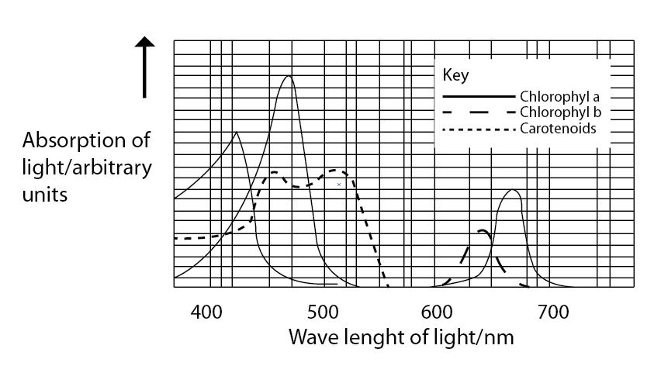

A scientist investigated the energy in light of different wavelengths reaching the ground in a forest. The energy measured was in:

Direct sunlight

Sunlight that had passed through the leaves of trees

**Figure 2 shows the results of this investigation.**

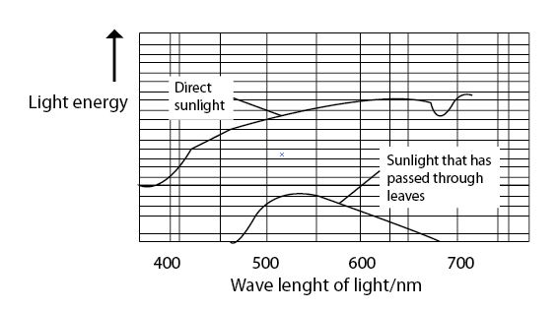

Sun leaves and shade leaves are two different kinds of leaves on beech trees. Sun leaves grow on branches exposed to direct sunlight, shade leaves grow on branches exposed to light that has passed through leaves. An ecologist collected sun leaves and shade leaves from beech trees and determined the mean mass of each photosynthetic pigment in both types of leaf. The results are as shown in figure 3

|  |  |  |
| --- | --- | --- |
| **Photosynthetic pigment** | **Mean mass of each pigment per m2 of leaf area/μg** | |
| **Sum leaves** | **Shade leaves** |
| Chlorophyll a | 299.3 | 288.9 |
| Chlorophyll b | 90.7 | 111.1 |
| Carotenoids | 0.10 | 0.07 |

1. Plot a suitable graph to represent the data in figure 3
2. Describe the absorption of light of different wavelength by chlorophyll
3. Comment on light absorption of different wavelengths by chlorophylls and carotenoids
4. Explain
5. The penetration of light through the forest
6. Why few species of plant can survive under shady habitats
7. Explain
8. The advantage of producing more chlorophyll b in shade leaves to beech trees
9. Why in leaves at the top of trees in a forest, carbon dioxide is often the limiting factor for photosynthesis
10. Each type of pigment is produced by a specific enzyme-controlled pathway. Suggest how the same plant can produce more pigment in some leaf cells than others
11. Suggest the morphological adaptations of plants for shady environment
12. With evidence explain the role of carotenoids to leaves of plants
13. The relationship between potassium ion concentration in the roots and sugar consumption at different oxygen concentration was investigated. The figure 1 below shows the concentration of potassium ions (Mgcm-3) and the rate of sugar consumption (mghr-1) by roots of fleshly uprooted plant when inserted in a bathing fluid at different oxygen concentration.

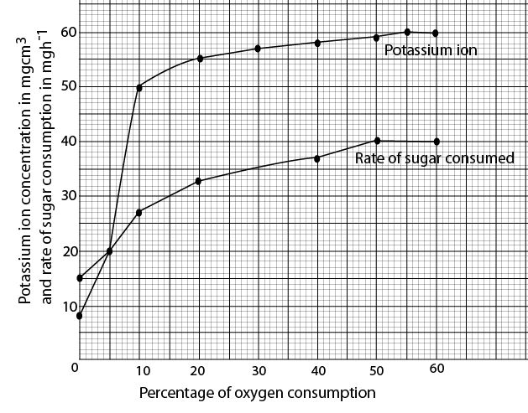

1. Compare the effects of oxygen concentration on potassium ion concentration in the roots and rate of sugar consumption
2. Explain the,
   1. Presence of potassium ion concentration in the roots without oxygen
   2. Relationship between potassium ion concentration and oxygen consumption
   3. Effect of increasing percentage of oxygen consumed on rate of sugar consumption
3. Predict change in concentration of potassium ions in roots and rate of sugar consumption if the experiment was to continue for some time up to 90% oxygen consumption. Suggest reasons for your answer

State other three factors other than oxygen concentration that could affect the rate of potassium ion uptake by roots.

1. Predict change in concentration of potassium ions in roots and rate of sugar consumption if the experiment was to continue for some time up to 90% oxygen consumption. Suggest reasons for your answer

State other three factors other than oxygen concentration that could affect the rate of potassium ion uptake by roots.

5. A graph in the figure below shows the rate of water movement over a 24 hour period in different parts of a tree. Study it and answer the questions that follows.



**(i) Describe the changes in the rate of water flow in the upper branches.**

**(ii) compare the changes in the rate of water flow in the upper branches and the trunk.**

**(iii) Explain how the results of the investigation support the cohesion tension theory.**

**(b) How are plant tissues for water movement adapted to this function?**

**SECTION B**

6. a) Explain what is meant by a naked DNA molecule.

b) Explain why DNA is referred to chemicals of life.

c) In what way is a DNA molecule;-

1. Different form RNA?
2. Similar to RNA molecule?

d) Describe how the molecule of trypsin can be obtained from the DNA molecule

e) Explain the significance of properties of water to the life of organism.

7 Explain briefly the meaning of the following terms in relation to enzyme structure and activity.

(i) prosthetic group (ii) co-enzyme (ii) active site (iv) activators

(b) Figure below shows the activity of bacterial enzymes at different PH and temperature.



Which graph represents the bacteria that live in?

(i) cool and neutral conditions

(ii) hot and acidic conditions

(c) compare the changes in the enzyme activity with temperature and PH for organisms tht live in hot and acidic environment to those that live in cool and neutral environment.

(d) with reference to enzyme structure, explain how the following factors affect enzyme activity ;

(i) PH

(ii) temperature

(e) Explain why the same enzyme may be able to work at different optimum PH and temperature conditions in similar organisms living in different environments.

(f) cellobiose and maltose are both disaccharides. Explain why amylase enzymes produced by microorganisms in the rabbit’s gut are unable to digest cellobiose.

8 (a) what is protein denaturation

(b) Explain the factors that may denature proteins

(c) discuss the role of proteins in living organisms.

9 (a) what is photoperiodism

(b) How does the photoperiod affect

(i) flowering

(ii) dormancy in plants

(c) how is the phytochrome system involved in photoperiodic control of flowering in plants.

10 (a) Distinguish between the fluid mosaic model and Danielli-Davison models of the plasma membrane

(b) Explain how the;

(i) Golgi bodies function in cells

(ii) plasma membrane allows transport of the materials across it.

**END**

**Tr Laban Duncans**

**Kisoro vision biology department 2019**